**13. ReactJS-HOL**

* Conditional rendering in React can be done in multiple ways. The most common approach is using if-else statements or the ternary operator (condition ? true : false) inside the render method or return statement. You can also use the logical AND (&&) operator to render something only if a condition is true. Another way is by assigning JSX elements to variables and returning them conditionally.
* To render multiple components in React, you can wrap them inside a parent component or a fragment (<> </>) if you don’t want to add extra nodes to the DOM. This allows grouping of multiple JSX elements and components together in a single return statement.
* A list component in React is a component that takes an array of data and returns a list of JSX elements by mapping over the data. It helps in dynamically rendering content like user lists, posts, or items in a cart.
* Keys in React are unique identifiers used when rendering lists of elements. They help React identify which items have changed, been added, or removed, which makes rendering efficient. Keys must be unique among siblings and are often set using IDs or unique values.
* Extracting components with keys means creating a separate child component for each item in the list and passing the key as a prop. This improves readability and structure of the code while maintaining React’s reconciliation process.
* The map() function is a JavaScript array method used in React to iterate over an array and return a new array of JSX elements. It is commonly used to render lists dynamically by looping through data and displaying each item as a component or element in the UI.

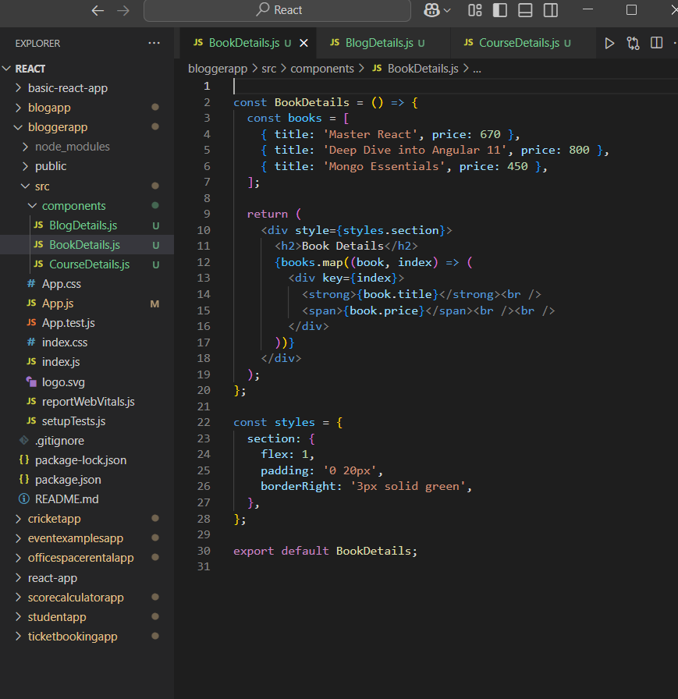

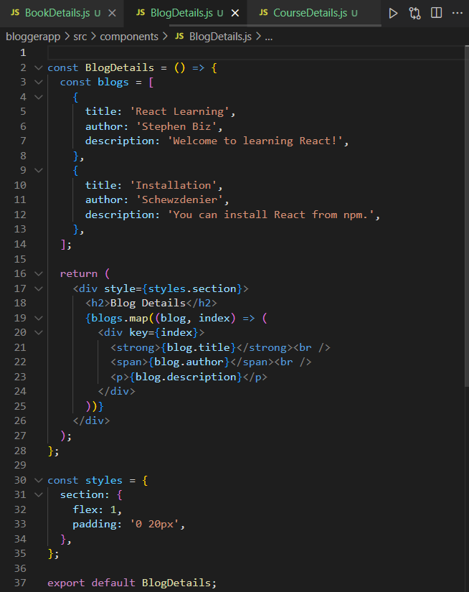

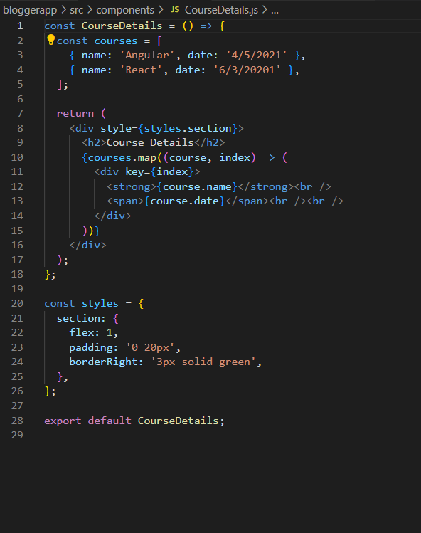

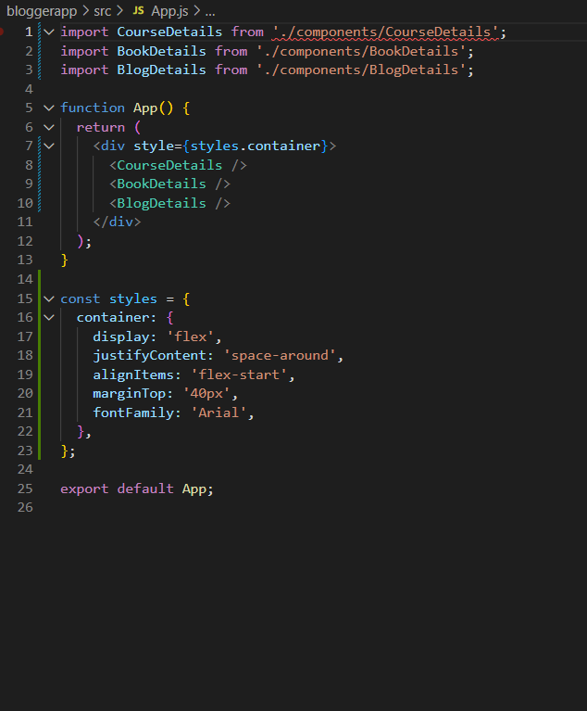

**Output**

